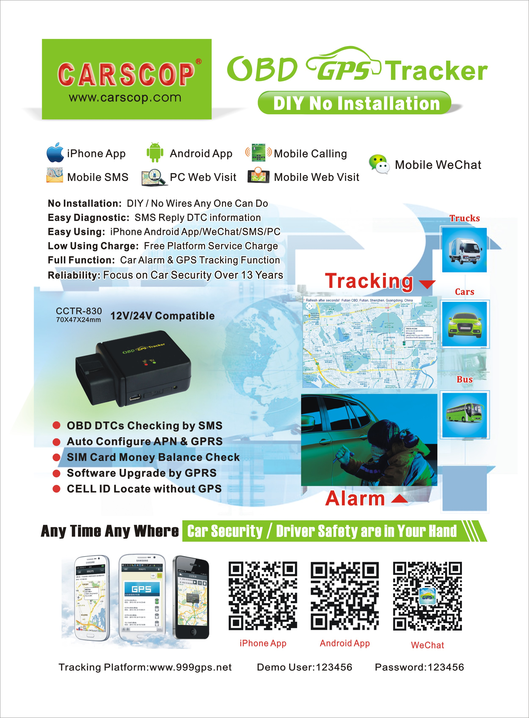
GPS Tracker & Tracking System:
Protect Your Car Security ! Make Your Life Safety !
Protect Driver Safety---Hidden installation & power down remove alarm, hi-jacking SOS function can help police to find car & driver easily and immediately, family can have better safety protection !
Protect Car Security---Move & shock alarm can be used as car alarm, when the car is attacked, the tracker will send SMS and make a call to the car owner with silence, no be be sound, theft don’t know the tracker has noticed the car owner, this make the GPS tracker has better protection than normal car alarm. Any where any time car security is in your hand !
Vehicle Fleet Management---For company vehicle or transportation fleet, one account can monitor all vehicle current location, history tracking, break Geo-fence, over speed, etc, It is easy and convenient to manage a fleet.

GPS Tracker: Enhance Working Efficiency ! Reduce Oil Cost !
Driver can not laze again--Every day working time and driving tracking easy checking, driver can not lie any more !
Easy fleet management--No matter how many vehicle in a fleet, one account can check every vehicle, PC / Mobile Phone / SMS / App / WeChat etc, any way can track any vehicle.
Shock / Move Alarm (Used as Car Alarm)
Driver will be very worry about the car security when the car is not in parking lots, after installing GPS tracker, if the car is attacked, the tracker will send SMS and make a call to car owner, no distance limited, even you can send SMS to turn off car engine if the car is stolen, any time any where car security is in your hand !
When the tracker send SMS or make a call to car owner, on be be sound, theft will not know the tracker has noticed the car owner, it is better than normal be be sound car alarm system, the normal car alarm system begin to be be sound, the theft will find the alarm and remove it, then the alarm is disarmed, and normal be be sound alarm only notice around people, you can not hear the sound far away or behind a wall. if the car is stolen, you can help police locate your car immediately, also you can track the car driving routing real time, this can help police find your car easily & fast !
Make a call to notice car owner: Send a SMS to notice car owner:
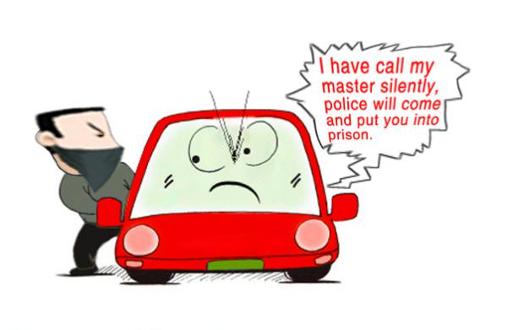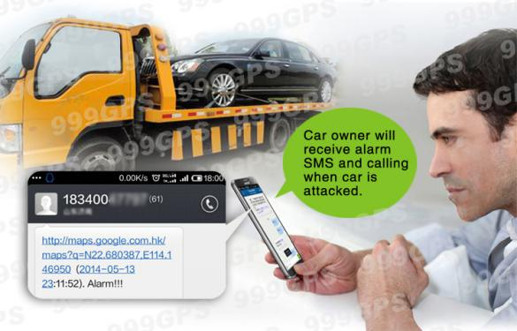
Current Location / History Tracking Playback
PC / SMS / App / WeChat / Web visit etc, any way can get current location any where any time, it is not necessary to worry about your family safety any more, even the car is hi-jack, also you can help the police to find your family and save them. Safety is the most important for you and me !
6 locate method, any one can help you check your car, car security is in you hand!
1: PC Web visiting:
Current Location History Tracking Playback
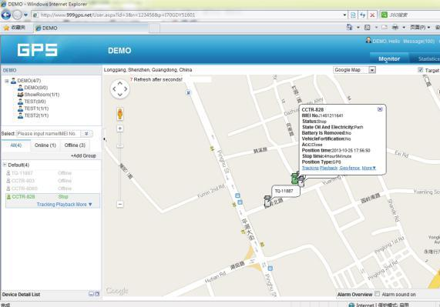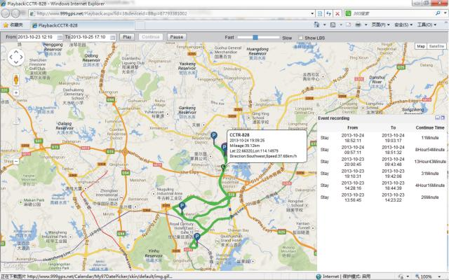
Just visit www.999gps.net by any PC with internet connection, login with the given user name & password, the current location will display, and specified date & time, you can playback any time history tracking, we will keep the history tracking data over 6 months to 12 months, it is not necessary to download any software, just visit website is OK.
2: Make a call or send a SMS to trigger sending back SMS with location description or Google map link.
The reply location will be XXX city XXX road XXX building, For example: 64-69 Sai Lau Kok Rd,Tsuen Wan,HonKong. if the location can not get in word, it will reply a google map link, click the link the location will display on map. For Example: https://maps.google.com/maps?q=22.67680N,114.15188E
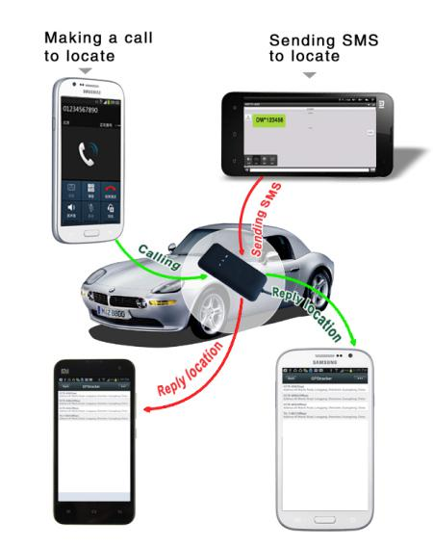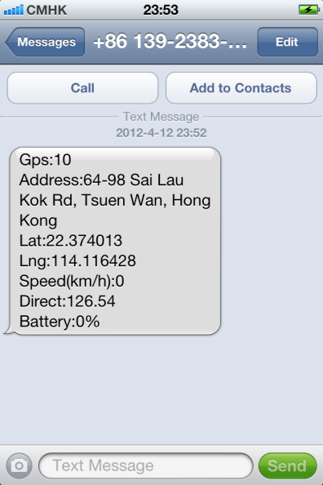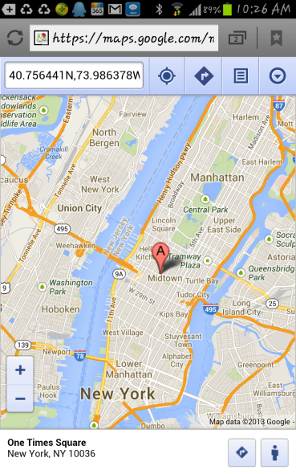
A: Make a call to the tracker, then hang up, a minutes later, the tracker reply the above SMS, it is very easy to use !
B: Send a SMS “123#” to the tracker also can trigger the tracker reply SMS with location description. Send a SMS “url#” to the tracker can trigger the tracker reply SMS with Google map link. it is very convenient.
3: iPhone & Android App
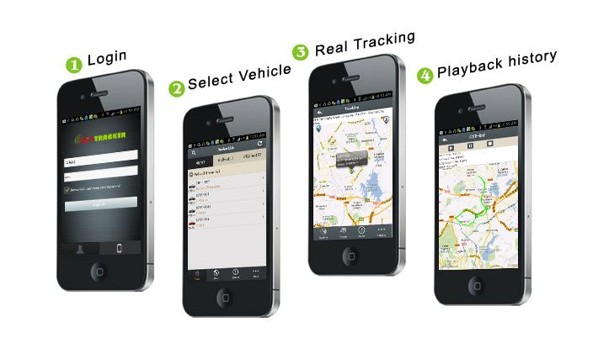
App can check current location & playback history tracking, also it can monitor fleet vehicle, now the iOs iPhone & Android app is available, Android app can be download on the platform by scan QR code or click the download link, iPhone app will link to the apple official app store, you can download and install the iPhone software on apple app store, it is free, and it is not necessary to do the IOS Jailbreaking, you just need register an apple ID with email and verify it on the app store https://appleid.apple.com is OK, the following is app store website link to download and install the app on iPhone :
https://itunes.apple.com/us/app/gpstrack1/id717568884?ls=1&mt=8
Also open app store on iPhone, Search “GPStrack1” app, the above app will display, click the “Free” and “Install”, and input your apple ID and password, the app will be downloaded and installed on the iPhone automatically.
App also can be used as car finding: When open app, your own location and your car location all can be display on the map (Enable your mobile phone GPS), also it can update every 30 seconds, you can look the map and walk to your car. (For underground park, your display location maybe is not your real location, it is cell locate location when no GPS).
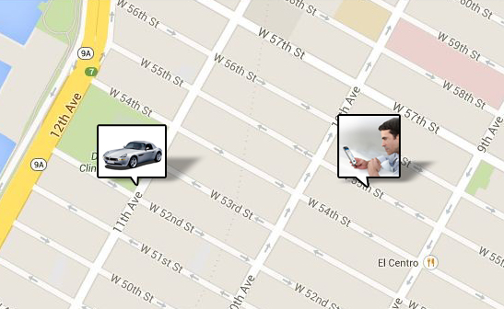
4: WeChat Locate
WeChat is a online live connecting software by text,voice or video through internet, it can be used for iPhone / Android / Windows / BlackBerry / Symbian mobile phone, just follow our official account GPStracker, and then send “platformloginname#password” to the account GPStracker to link your personal WeChat account and your tracker login name together, then later just send 123 to GPStracker on WeChat, it will reply the current location with text description & Google map, it is easy and convenient. For how to download, install and register WeChat please visit: http://www.wechat.com or http://weixin.qq.com .
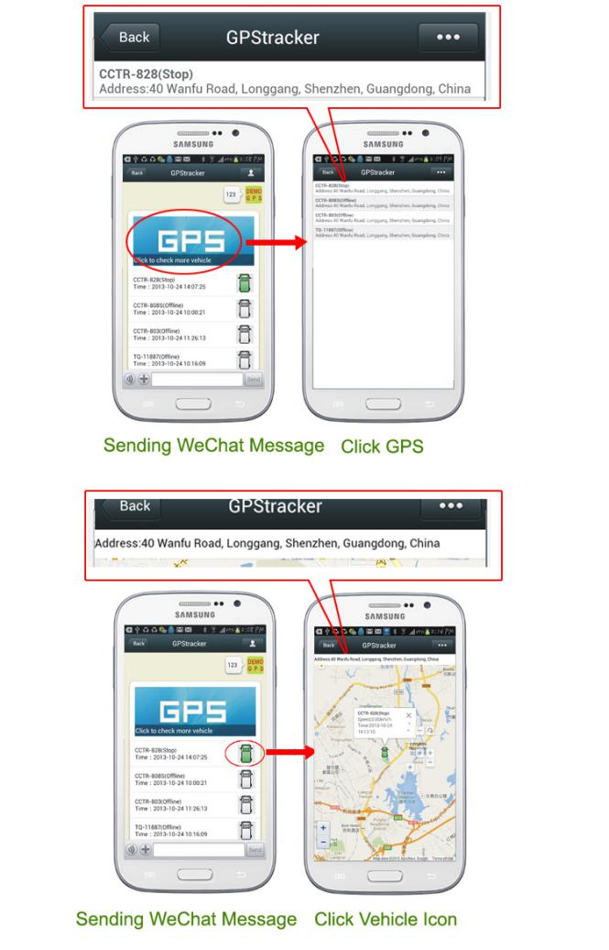
5: Mobile website visit
Use mobile phone explorer to visit website www.999gps.net, login with the same user name & password, the same function with PC website visiting can be done, the only difference is the screen is smaller.
6: Mobile wap website visit
For old non-smart phone, Use mobile phone explorer to visit website wap.999gps.net, login with the same user name & password, current location on the map will display, the wap website visit only can locate current location, it can not playback history tracking. it is only used to suit for old mobile phone locate to display map.
This OBD GPS tracker is no installation, just inert the tracker to OBD II socket is OK, it is not necessary to connect any other wires any more, just like you use your car charger to recharge your mobile phone in the car, so it has not any damage or any disturb on the vehicle.
This OBD GPS tracker is no installation, just inert the tracker to OBD II socket is OK, it is not necessary to connect any other wires any more, when the car is driving, the GPS tracker power is supply by the car engine generator, when the vehicle stop moving, the tracker will go to sleep mode to save battery power, the current is less than 5 mA, just like a mobile phone is standby, so it has not any damage or any disturb on the vehicle.
Normally GPS tracker has 2 kind of charge: SIM card data charge and GPS tracking platform service charge.
- SIM card charge: GPS tracker need use GSM network to send GPS location data to internet server by GPRS, so you need pay the SIM card charge, normally the GPS tracker will cost 10-20M byte data every month, it is better to order an data package to save money. If you use SMS locate, it also need cost SMS charge, and if you use listen function, it will cost calling charge, so order only data SIM card and order an 10-20M data package can save money.
- GPS tracking platform service charge: GPS tracker need send GPS location data to internet server, we should develop an special software for the server, and rent an place in the main line internet machine room, also we need monitor & maintain the server running 24 hours, all these make your tracking service running any time any where, so normally customer need pay GPS tracking platform service charge, some company supply one year free, normally one year is 10-20USD, 999GPS tracking platform www.999gps.net is life time free service charge, we only add a little profit on the tracker instead of service charge, it is a big benefit for the customer, it is not necessary to pay platform service charge any more, any time any where just insert the SIM card into the tracker, you can use the GPS tracker free.

For example: if the GPS tracker will use 5 years, first year is free, the left 4 years need to pay at least 4x10 or 4x20 USD to service company, add one year service charge on the tracker to get life time free service charge, it is a big benefit, after calculate you will say i like free !
CARSCOP start from 2001, keep running over 13 years, CARSCOP focus on car security, one way, two way and GSM car alarm system sale to many country, and CARSCOP start manufacture GPS tracker and tracking service from 2008, and by now total almost million tracker devices (Most in oversea market), and the tracker devices have been passed the FCC & CE proved, by now the market and CARSCOP running is very good, and CARSCOP will develop more & more new car electronic products to sale in the market, even if CARSCOP change products from GPS tracker to other products, CARSCOP promise to keep the server running till the last product stop using, this is a grantee of a 13 years company, it is more reliable than a new company, so the tracking platform will not close until your tracker stop using.
CARSCOP also sale GPS tracker in our local market, and CARSCOP charge the platform service fee in our local market, CARSCOP can get profit from the platform service, so CARSCOP will not close the tracking platform.
All CARSCOP GPS tracker can change IP to other platform, just send a SMS is OK, and we open the GPRS protocol, and our protocol is popular in the market, it is easy to add our protocol to new platform, so even if the CARSCOP platform can not be used, also you can change to other tracking service company platform.
- This tracker is no installation, OBDII interface design, just insert the tracker to the car OBDII socket is OK, no damage to the car wirings, no interfere to the car circuit, no hurt to the car battery.
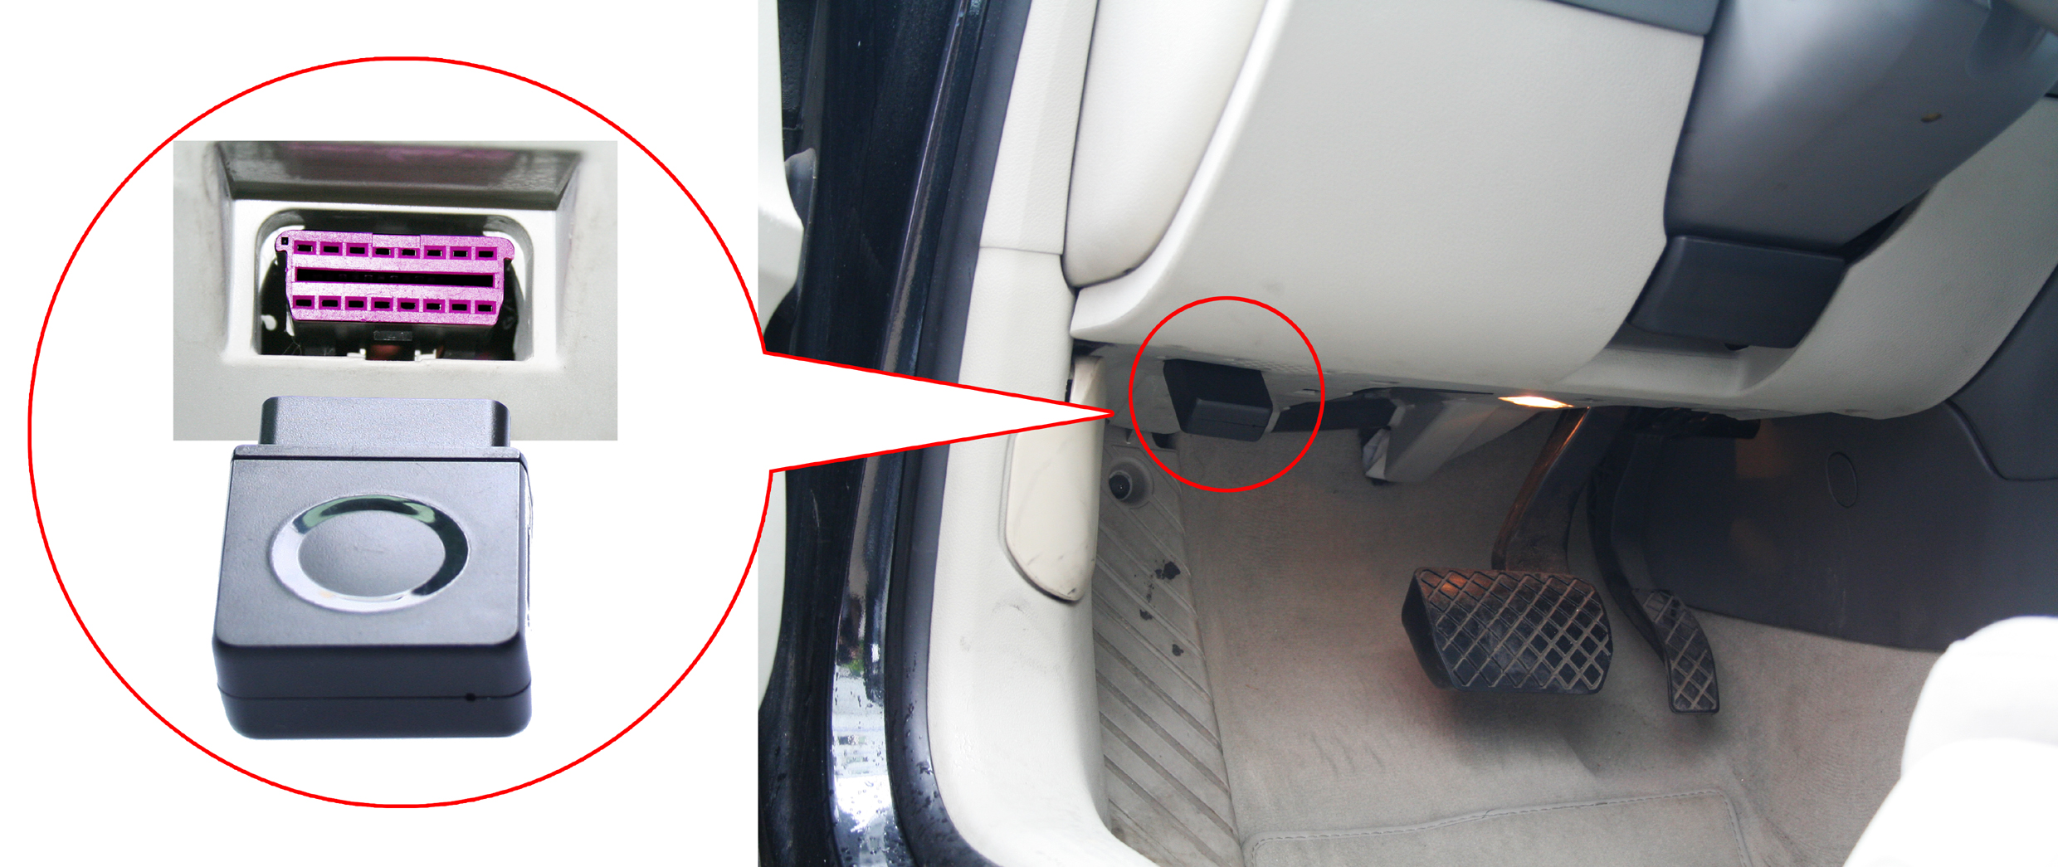
- Send a SMS can check car OBD DTCs and car status, this can help car fixed workers to check the car problem when your car have problem, and it is not necessary to drive the car to fixed factory, it is easy and convenience.
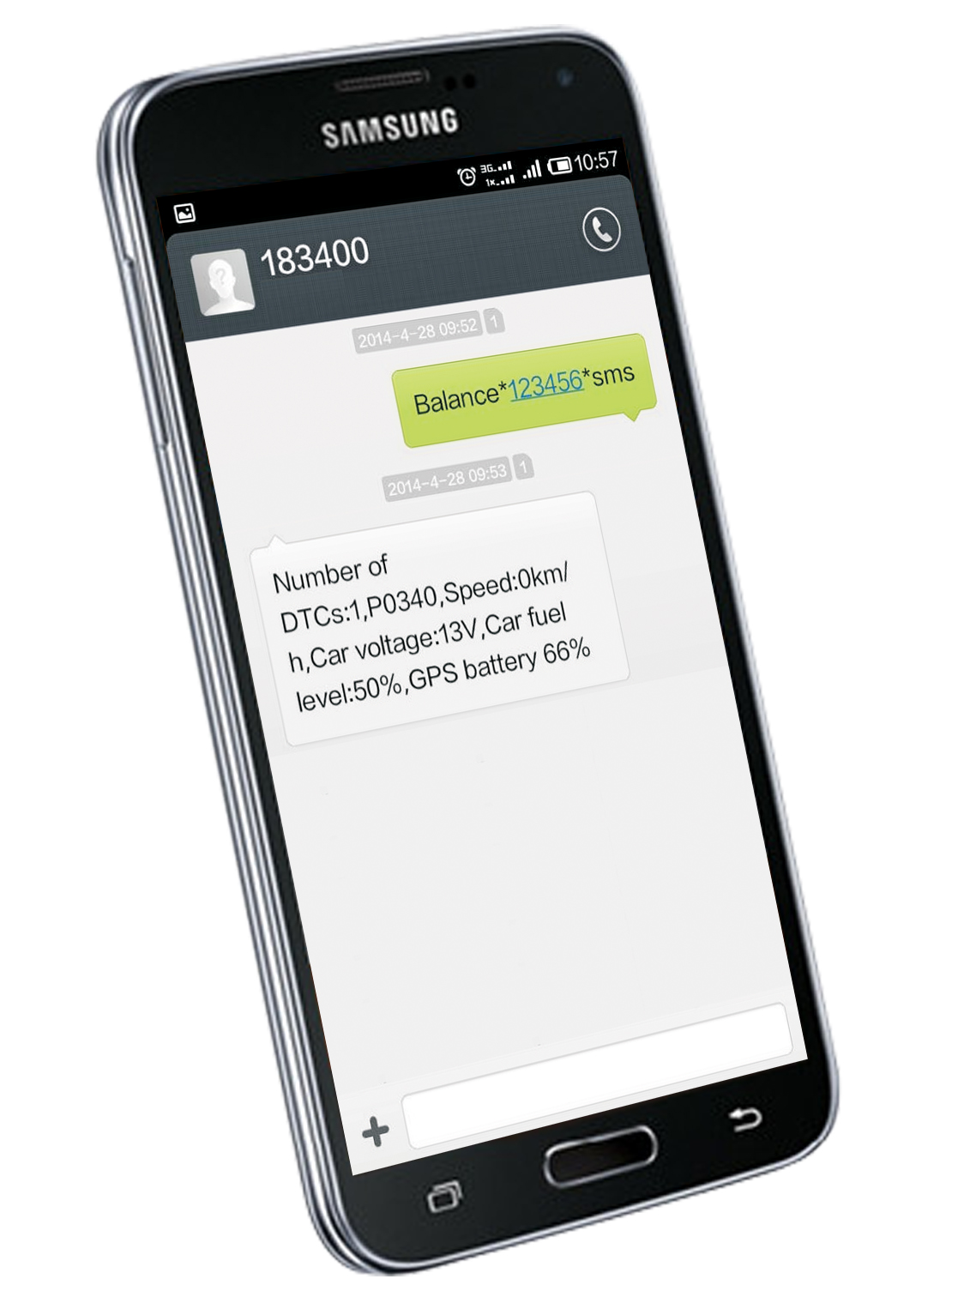
- Tracker software can be upgraded by GPRS, just send a SMS is OK, it will upgrade from internet by GPRS, it is not necessary to connect to any computer, it is easy and convenience.
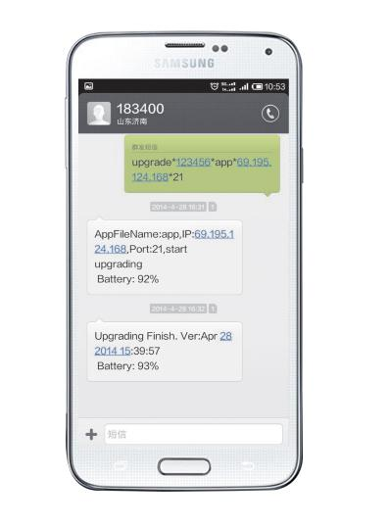
- The tracker will auto download and configure APN & GPRS setting from internet, it is not necessary to set by user, if the tracker sim card is changed, the system will auto change the APN & GPRS, if the setting is not correct, also you can change it by sending SMS, when customer buy the tracker just insert the sim card is OK, the tracker can be tracked.
- This tracker has money balance SMS checking function, set the balance checking USSD number, and later just send a SMS can check the tracker sim card money balance.
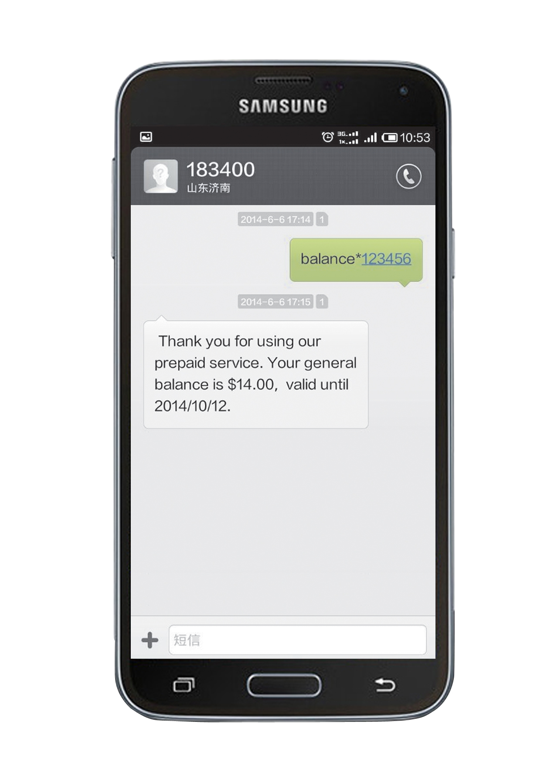
- Built in microphone for listening sound in the car, just send a SMS you can listen the sound in car, and the driver will not know you are listening.
- When the tracker go the place without GPS signal, for example underground park, tunnel, building etc, the tracker can be located by CELL ID, this location can help you find the car(The precision of CELL ID locate is not very high, mabe reach to few hundreds meters, this precision is decided by the density of the GSM network base station).
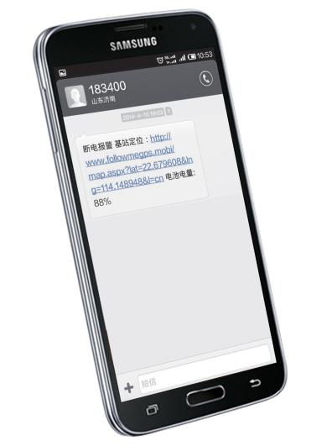
- This tracker built in rechargeable battery, when the tracker is removed or the car battery is low, the tracker will send SMS to car owner to notice, this can avoid the driver removed the tracker.
- Our tracking platform has charging management function, distributor account can create fleet user or single user, and move the tracker to the fleet or single user, also distributor can extend expired date for end customer, so we can help distributor to start GPS tracking charging service.
- We can supply personal domain name & personal login page with distributor LOGO and address (just like your own server and platform), also we can develop personal iPhone & Android App with distributor LOGO, Personal WeChat official account for locating also can be supplied, Personal download website for tracker manual & platform user guide also can be supplied.
This tracker is no installation, OBDII interface design, just insert the tracker to the car OBDII socket is OK, no damage to the car wirings, no interfere to the car circuit, no hurt to the car battery, customer can DIY.
1.SIM card installation
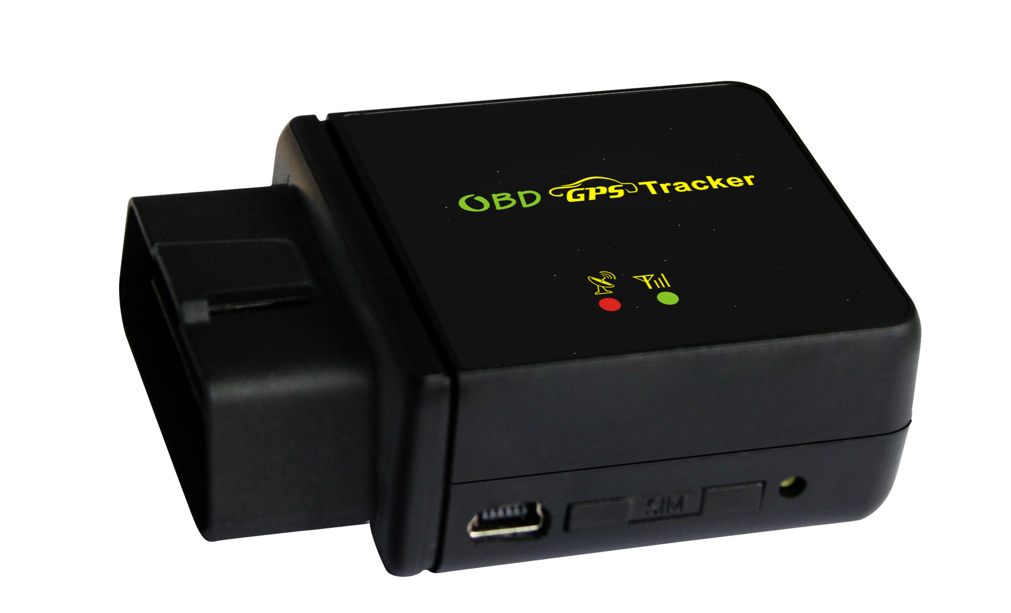
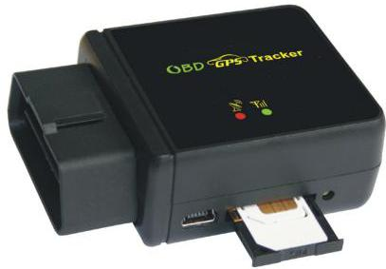
Metal face to up

SIM Release

This tracker use 2G GSM network, and it upload tracking only through GPRS, it can not work in CDMA network or 3G(WCDMA or CDMA2000) network. (Some 3G SIM card can use in 2G GSM network, this kind of 3G SIM card can be used in this tracker), and please disable the PIN code of the SIM card, this SIM card phone number is the tracker number and all the operations (calling and sending SMS) to the tracker is this number.
- Normally the platform service is active automatically by the tracker first uploading the location, the default user name is the last 7 digital of the tracker ID (print on the back of the case), and the password is same with user name, user can change the password himself. For example ID is 1451217388, then the default user name & password are 1217388. if user like to move many tracker to a fleet, call your distributor is OK.
- Please confirm the vehicle battery voltage, CCTR-830 working voltage is 9-45V, normally the car or truck or bus battery voltage is 12V or 24V, so most of the cars, trucks or buses can install CCTR-830. For electric motor the battery is high than 45V (Maybe 48V or 60V) please select our high voltage model CCTR-820 (9-80V).
- Insert the tracker to the OBD socket is OK, it is not necessary to do any other installation, all cars later from year 2000 have OBDII interface, the OBD socket normally is under the car panel, if you can not find the OBD socket, check your car manual to find or call your car manufacturer hot line to confirm the OBD.
- Check the tracker LED flash (red & green LED flash once means work well), if the GPS & GSM signal is ok, login the website www.999gps.net to check the location is update or not.
- If the OBD socket place GPS signal is very weak, maybe the tracker can not locate, then you need add an extend OBDII wires, and then you can place the tracker to other place that have better GPS & GSM signal.
- Driving the vehicle a distance, and check the tracking on the platform is correct or not, other wise move the tracker to other place and try again.

The tracker manual can be read and download on the internet, scan the follwong QR code or click the link can download the manual.



Manual(Word) Download QR Code Manual(Pdf) Download QR Code
Tracker Picture
Accessory (Optional, not including in the package)
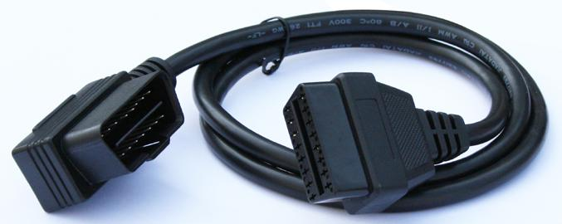

Specification:
GSM Module | SIMCOM | GPS Module | U-blox or MTK
GSM Frequency | 850/900/1800/1900Mhz (4 Band) | GPS channel | 32 channels
GSM / GPS Antenna | Built in | Locate precision | 10-20 Meters
GPS Cold Start Time | 36 seconds | GPS Hot Start Time | 1 second
Working Voltage | 9-40V DC | Recharging Current | < 5V/300mA
Standby Current | < 10 mA | Uploading Current | <200mA / 5V
Battery | 300mAh | Working Temperature | -20 ⁰C to +55 ⁰C
Absolute Temperature | -35 ⁰C to +70 ⁰C | Storage Temperature | -40 ⁰C to +80 ⁰C

CCTR-830
DIY No Installation OBDII GPS Tracker with iPhone & Android App Online Diagnostic & Listen Sound

Key Specifications/Special Features:

- OBD II interface, DIY no installation
- Online diagnostic, SMS reply car DTC & car status
- Online software GPRS air upgrade
- Auto download & configure APN & GPRS, Also can be set by SMS
- Tracker SIM card money balance SMS checking
- Built in microphone for listen sound in car
- Cell ID locate (base station locate) without GPS
- Built in memory to record track without GSM network
- Working Method: GPS located + upload with GPRS GSM network
- Upload current location to internet server
- Built in GSM & GPS high sensitive antenna
- Built in rechargeable battery for power down alarm & tracker removed
- Shock alarm (calling alarm & SMS sending) can be used as car alarm
- Power down alarm & shock alarm can be sent by SMS or calling
- Wide working voltage (9-45V), Car,& truck all can be used
- Sending SMS to set GPS tracker, easy to use
- GPS operating need password to protect user privacy
- Use high sensitivity GSM & GPS module
- Stop uploading after stop moving 2 minutes to save car battery life
- Built in move sensor, begin uploading immediately if car begin to move
- Device can be located by SMS or calling without platform server
- If the object enters no GPS area, it will report the last position tracked
- Upload IP address can be set by SMS
- Platform & tracker manual can be read & download on platform
- Tracker working status & setting can be check by SMS
- Life time free platform Service charge (Our free platform www.999gps.net )
- Distributor can apply charging GPS tracking service with our assistance
- Muli-Level user for Agent / distributor / fleet / single user etc.
- Personal domain name & login page with customer logo can be applied
- Open GPRS protocol to client for adding protocol to platform
- Support iPhone & Android App / WeChat / SMS / Calling locate
- Platform user password can be changed by user to protect user privacy
- Over speed alarm / Geo-fence break alarm can be set on platform
- Running report can be read & export by month and day
- Compatible with IE / Fire fox / Chrome / Safari, not necessary download software
- History tracking data keep 6-12 months
- Suit for cars / bus / truck / taxi / rent cars etc.
- Tracking platform: www.999gps.net, Demo user:123456,Password:123456

Primary Competitive Advantages:

- OBD II interface, DIY no installation
- Online diagnostic, SMS reply car DTC & car status
- Online software GPRS air upgrade
- Auto download & configure APN & GPRS
- Tracker SIM card money balance SMS checking
- Built in microphone for listen sound in car
- Cell ID locate (base station locate) without GPS
- Built in memory to record track without GSM network
- Shock alarm (calling alarm & SMS sending) can be used as car alarm
- Support iPhone & Android App locate / WeChat locate / SMS locate
- Life time no platform Service charge (Our free tracking platform)

Package list
1 main unit, 1 tracker manual(CD or Print), 1 platform manual (CD or Print).

Main Dimension: 70mm*47mm*24mm
Main weight: 55g
Package: Color box
Package Dimension: 130mm*92mm*58mm Weight: 0.30kg

Compare with other similar tracker
Function | XX08 or similar | CCTR-830
OBD DTCs Checking by SMS | X | V
CELL ID locate | X | V
SIM card money balance check | X | V
Auto Configure APN & GPRS | X | V
Software air upgrade by GPRS | X | V
Working voltage | 9-32V | 9-45V
Built in backup battery | X | V
Power down alarm | X | V
Shock alarm | X | V
calling trigger SMS locate | X | V
Power saving mode | X | V
Sleep time can be set | X | V
GSM module | Dual Band 900/1800Mhz | 4 Band 850/900/1800/1900 Mhz
The following is the same function
GSM & GPS Antenna | Built in | Built in
Web & mobile locate | V | V
Mobile App locate | V | V
WeChat Locate | V | V
Reply SMS location description | V | V
History tracking playback | V | V
Break geo-fence alarm | V | V
Over speed alarm | V | V
Speed report (Year/month/day) | V | V
Alarm report (Year/month/day) | V | V
Running report (Year/month/day) | V | V

CARSCOP 999GPS Tracker Selection Guide
Model | CCTR-830 | CCTR-828 | CCTR-821 | CCTR-820 | CCTR-808S | CCTR-800 | CCTR-811
Year of Product | 2014 | 2013 | 2013 | 2014 | 2013 | 2011 | 2013
DIY no installation | V |  |  |  | V | V
Suit for vehicle | V | V | V |  | V | V | V
Suit for electronic motor |  |  |  | V
Suit for person |  |  |  |  | V | V
OBDII & DTCs diagnostic | V
SIM card balance SMS checking | V
Auto Configure APN & GPRS | V | V | V | V | V
Cell ID locate without GPS | V |  |  |  | V
Solar panel power supply |  |  |  |  | V
IP56 water-proof |  | V |  | V | V | V
Magnetic pin attract on metal |  |  |  |  | V | V
Remote Turn off engine |  | V |  |  |  |  | V
Built in microphone | V
External microphone |  |  |  |  |  |  | V
External SOS button |  |  |  |  |  |  | V
Power down removed alarm | V | V |  |  |  |  | V
Shock sensor control uploading | V | V | V | V | V | V | V
Shock sensor car alarm | V | V | V | V | V | V | V
GSM GPS antenna built in | V | V | V | V | V | V
External GSM GPS antenna |  |  |  |  |  |  | V
Record last position without GPS | V | V | V | V | V | V | V
upload interval user change | V | V
User control start upload location |  |  |  |  | V
Real Time upload location | V | V | V | V | V | V | V
Free platform service charge | V | V | V | V | V | V | V
History data keep 6-12 months | V | V | V | V | V | V | V
iPhone/Android/WeChat locate | V | V | V | V | V | V | V
Software GPRS air upgrade | V
Software PC upgrade |  | V | V | V | V
Built in rechargeable battery | 180mAH | 250mAH | 0 | 0 | 4000mAH | 2000mAH | 450mAH
Battery working time(Standby) | 5-10 H | 6-12 H |  |  | 40 days | 7-10days | 1-2days
Battery working time(Uploading) | 1-2 H | 1-3 H |  |  | 40 H | 5-10 H | 5-10 H
Working voltage | 9-45V | 9-45V | 9-45V | 9-80V | 5V | 5V | 9-32V
Dimension (LxWxH Unit:mm) | 70x47x24 | 90X45X14 | 52X39X15 | 52X39X15 | 87X60X28 | 69x48x26 | 82x60x13
Weight(Unit:g, only main unit) | 55 | 60 | 35 | 35 | 230 | 130 | 80

We Focus on Car Security Over 13 years !
SHENZHEN CARSCOP Electronics Co., Ltd.
Addr: Building A1, YuanLing North Road, E-GongLing, PingHu, Shenzhen, China.
Homepage: www.carscop.com Email：sale@carscop.com
Tel:0755-33835288 84005500 Fax:+86-755-33823966
Company Registration Number: 440307105331986
Company VAT Number: 440301727173631
Paypal / Alipay / Escrow: pay@carscop.com
Globalsources 12 years Verified Supplier:
http://www.globalsources.com/carscop.co
Alibaba 4 years Verified Gold Supplier:
http://carscop.en.alibaba.com/
BV Certificate Factory Video:
http://www.999gps.org/carscop/BV-Vedio-CARSCOP.wmv
BV Supplier Assessment Certificate:
http://www.999gps.org/carscop/BV-Certificate-CARSCOP.jpg
BV Certificate Supplier Report:
http://www.999gps.org/carscop/BV-Report-CARSCOP-Supplier-Assessment.pdf
BV Certificate Main Products Report:
http://www.999gps.org/carscop/BV-Report-CARSCOP-Main-Product.pdf
Swiss SGS Audit Report:
http://www.999gps.org/carscop/SGS-Report-CARSCOP.pdf

